Exercise: Building and optimizing a data model

Introduction
You should now understand the fundamentals of data modeling in Power BI. In this exercise, you’ll apply your knowledge of these concepts by building and optimizing a data model in Power BI.
By completing this exercise, you’ll demonstrate your ability to:
- Work with advanced data models.
- Make use of DAX in Power BI.
- And optimize a model for performance in Power BI.

Scenario
Adventure Works’ sales are stagnating, and a growing inventory issue contributes to the problem. You're provided with sales figures, manufacturing data, and inventory levels. You need to turn this information into actionable insights so Adventure Works can solve its issues.
By building and optimizing an efficient data model, you can revolutionize how Adventure Works operates and help to align its products, markets, and strategies for success.

Instructions
Download and open the Adventure Works Power BI report titled AdventureWorksSales.pbix and follow the prompts below to complete the exercise.

Step 1: Download and import the data model.
- Download and save the Power BI report AdventureWorksSales.pbix. The data model contains two datasets: Customers and Orders.
- Access the model for editing by selecting Data view.

Step 2: Optimize data types.
Your next step is to optimize the data types for the Customers and Orders tables so that the data model functions efficiently and accurately.

Optimizing Data Types for the Customers table
- Select the Customers table from the fields pane.
- Access the Column tools tab on the top toolbar and navigate to the Data type option.
- Assign data types to each column as follows:
- Name = Text
- Surname = Text
- Location = Text
- Date of Birth = Date
- Phone Number = Text
- Membership Tier = Text
- Customer Source = Text

Optimizing Data Types for the Orders table
- Now that you have optimized the data types for the Customers table, you need to do the same for the Orders table. Select the Orders table from the Fields pane.
- Take a moment to observe the first 10 records. Note which record has the highest Order Quantity value. Next, note which payment method was most used.
- Access the Column tools tab on the top toolbar and navigate to the Data type option.
- Assign data types to each column as follows:
- Order Total = Decimal number
- Order ID = Whole Number
- Customer ID = Whole Number
- Product ID = Whole Number
- Order Date = Date
- Order Status = Text
- Order Quantity = Whole Number
- Payment Method = Text
- Billing Address = Text
- Discounts = Decimal Number
- Shipping Fee = Decimal Number
- Tracking Number = Text
Tip: You can assign a data type by accessing the Column Tools tab on the toolbar and selecting the Data Type option.

Step 4: Build and configure the model relationship.
- Access Model view to view the tables in your data model.
- Connect the Customers and Orders table using the Customer ID fields.
- Define the relationship between these two tables as One-to-many.
- Change the cardinality selection from its current state to One-to-many.
- Establish a Single cross filter direction.
- Save the changes made to the data model.
Tip: You can define a relationship by double-clicking the connecting line.

Step 5: Disable Auto date/time.
- Your final task is to disable the Auto date/time feature so you can manually maximize your model’s performance. Access and disable the Auto Date/Time feature.
- Apply your changes.
Tip: You can access the Auto Date/Time feature from the Options menu’s Data load option.

Conclusion
By following these steps, you have demonstrated your ability to work with advanced data models, use DAX in Power BI, and optimize a model for performance in Power BI.
In addition, by building and optimizing an efficient data model, you’ve revolutionized how Adventure Works operates and helped the company to align its products, markets, and strategies for success.

Solution

Exemplar: Building and optimizing a data model
Listen to reading
7 minutes

Overview
In the exercise Building and optimizing a data model, you were asked to put into practice what you have learned about building and optimizing data models in Microsoft Power BI.
Your task in this exercise was to build and optimize a data model for Adventure Works to help the company align its business for success. More specifically, you were asked to:
- Optimize the data types in the Customers and Orders tables to ensure efficiency and precision in data processing and calculations.
- Identify potential relationships between datasets and highlight the relationship between Customer ID columns in the Customers and Orders tables.
- Construct a one-to-many relationship between these tables, interpreting the connection that one customer can have multiple orders.
- To further streamline your data model's performance, you were required to deactivate Power BI’s Auto Date/Time feature, giving you more control over date fields.
This reading provides you with a step-by-step guide for completing these tasks. It also includes screenshots that you can compare against your own work.
You can review the techniques for this exercise in this course’s video items.

Step 1: Download and import the data model.
- Download the workbook from the exercise page on the Coursera platform. Open the workbook on the Microsoft Power BI platform.
- Select the Data View icon on the left vertical toolbar to switch your workspace to the Data View, where tables and their corresponding fields are displayed.
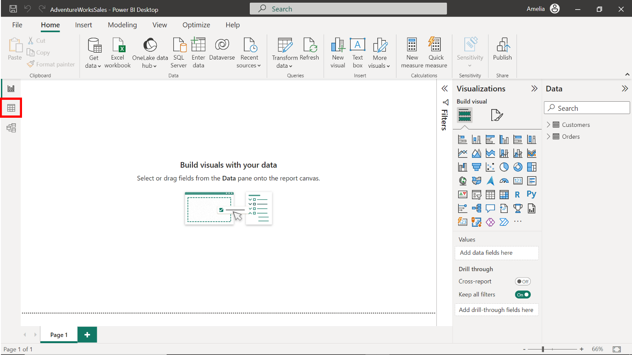

Step 2: Optimizing data types.

Optimizing Data Types for Customers Table
- Select the column labeled Customer ID.
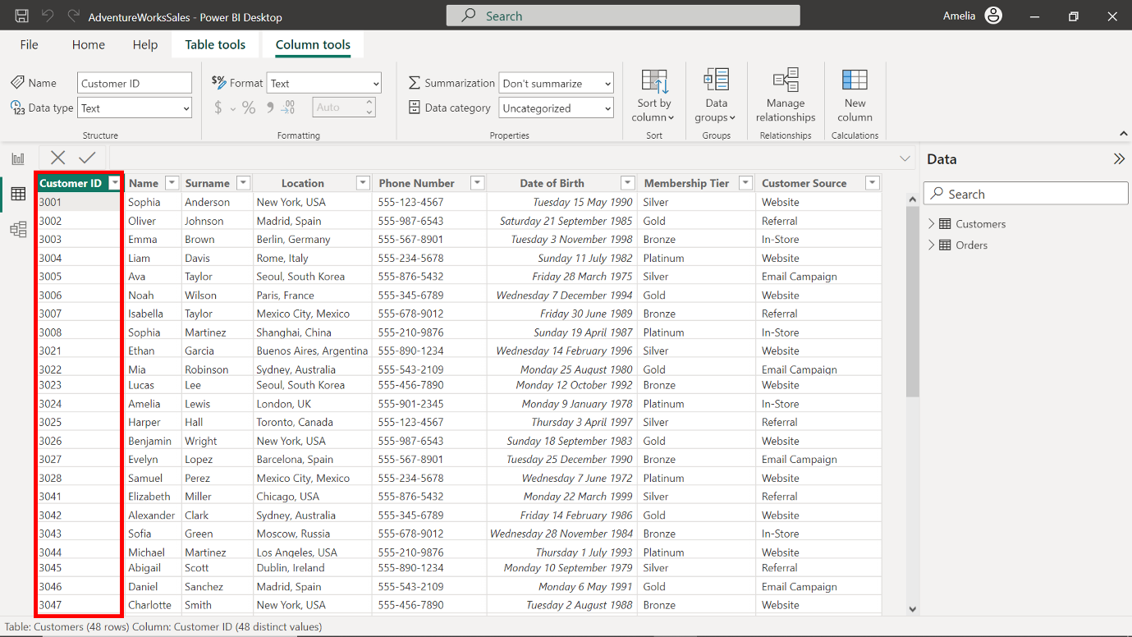
- Access the Column tools tab on the top toolbar. Select the option labeled Data type.
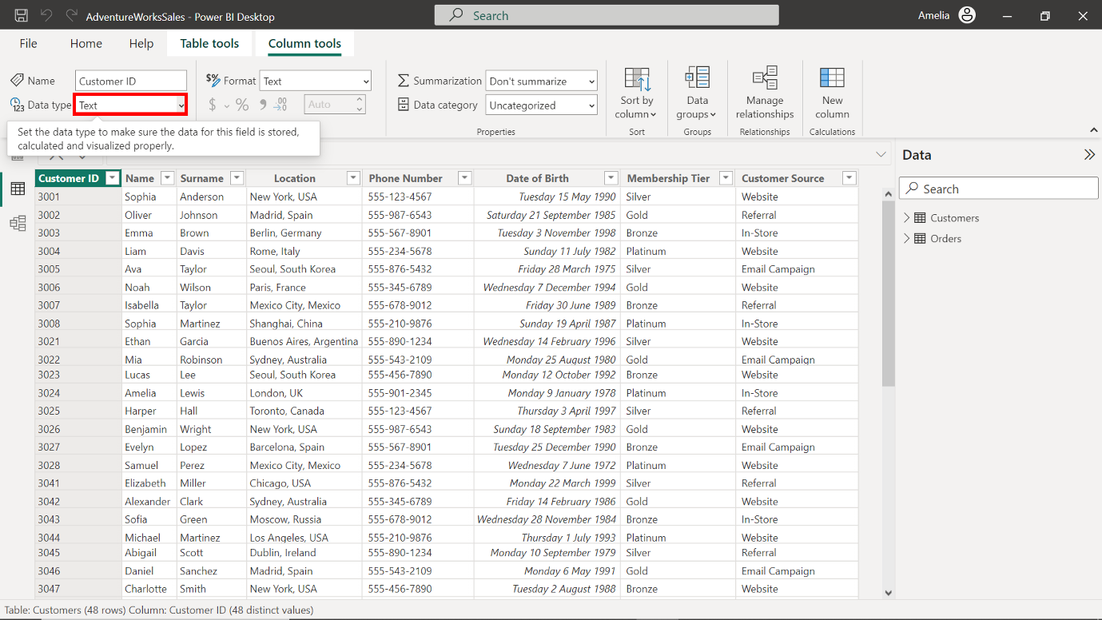
- Upon selecting the Data type option, a dropdown will appear. For unique identifiers that are numbers, Whole Number is often the best fit.
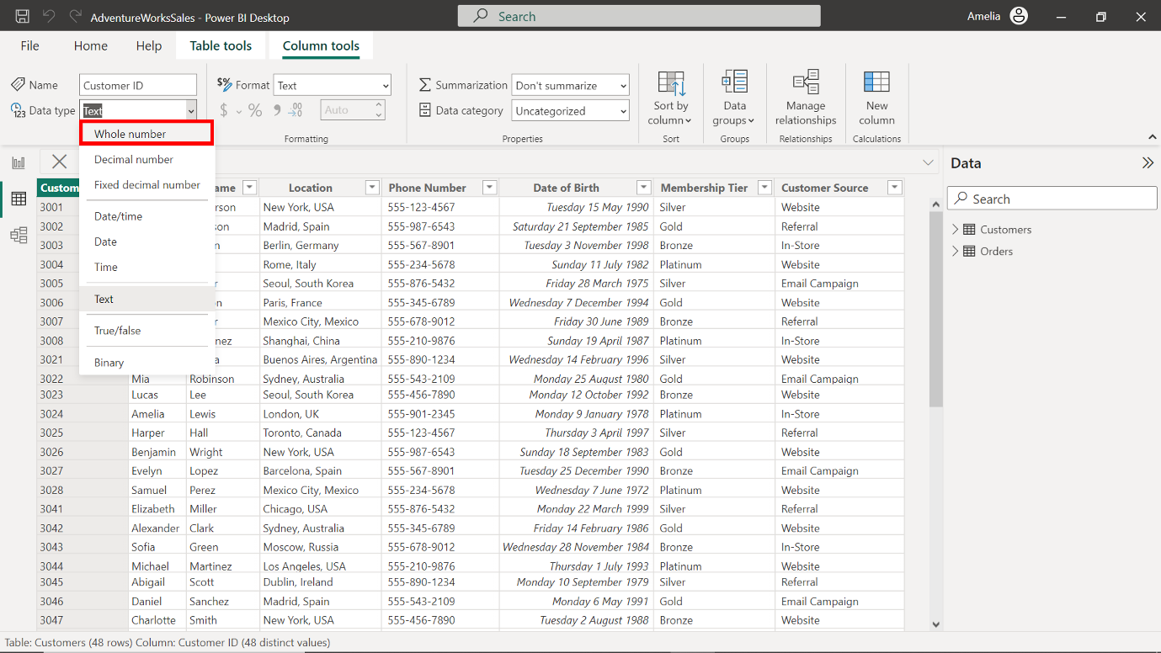
- Select Whole Number to assign it to the Customer ID column. Accurately classifying the Customer ID as a whole number safeguards against potential data mismatches or misinterpretations during future analysis.
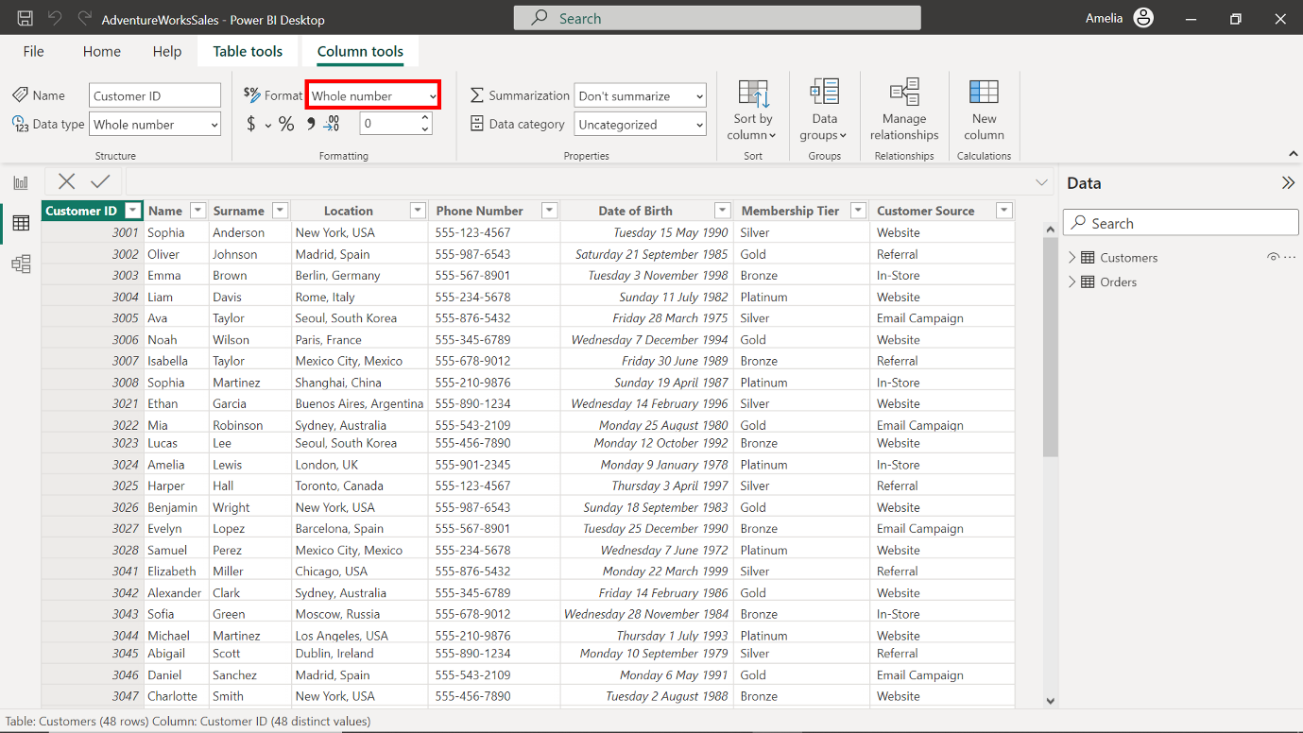
- The Adventure Works Customers dataset contains multiple columns, and each must be optimized to ensure accurate reporting. To complete the optimization of the data types, repeat steps 1 - 4 for the remaining columns as follows:
- Change the data type of the Name column to Text.
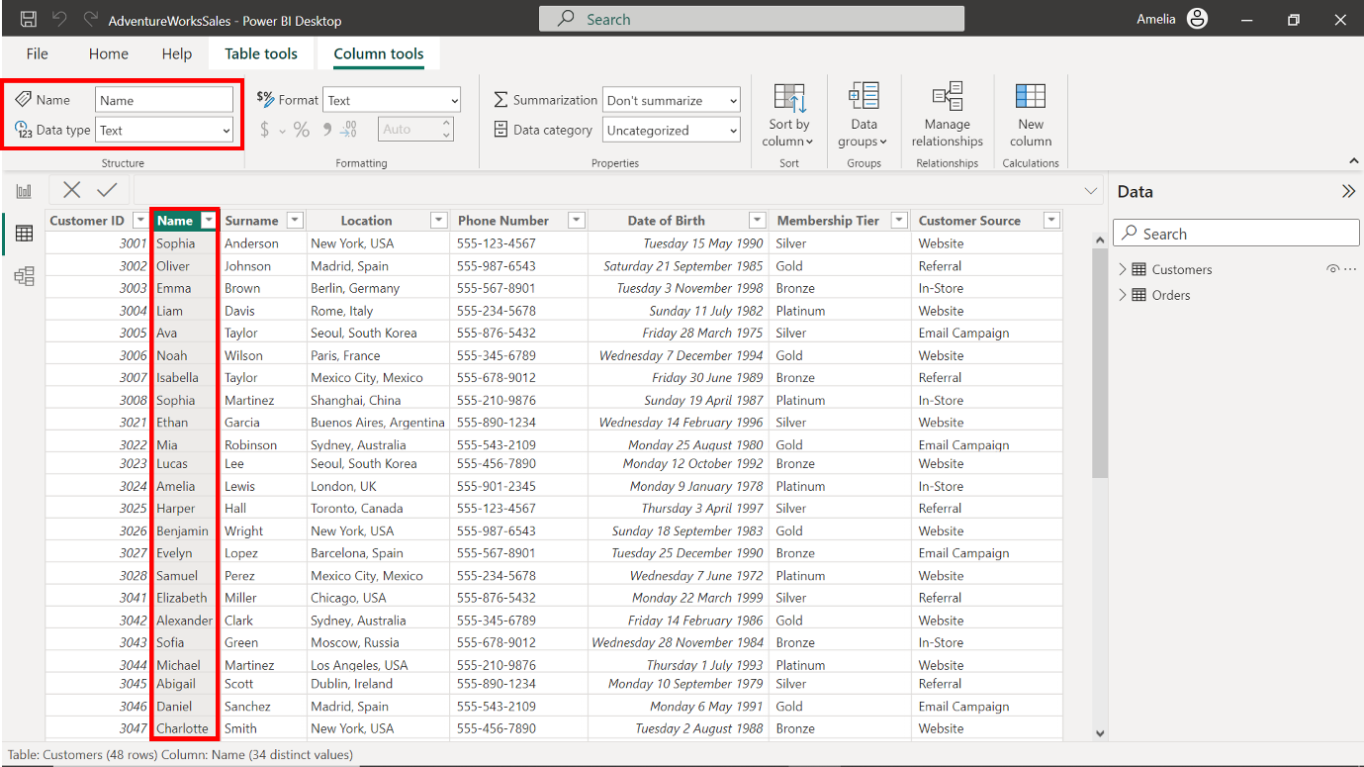
- Change the data type of the Surname column to Text.
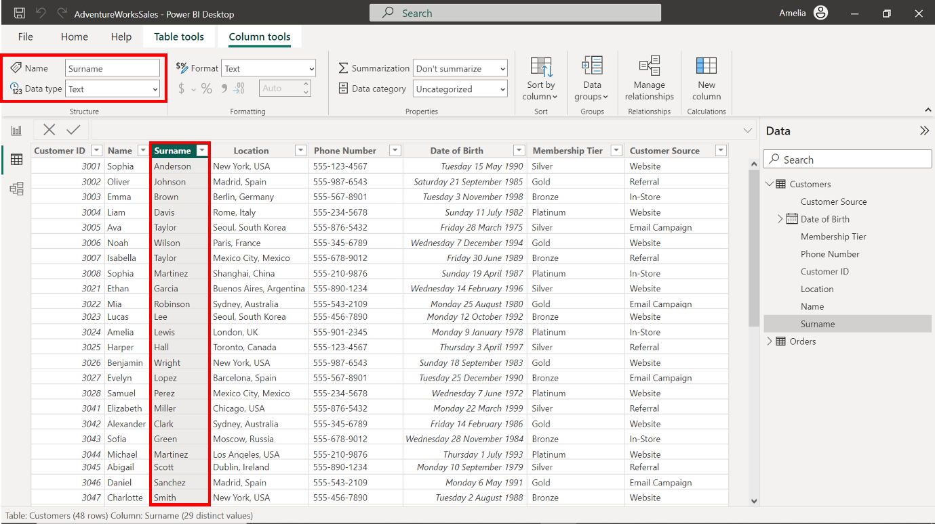
- Change the data type of the Location column to Text
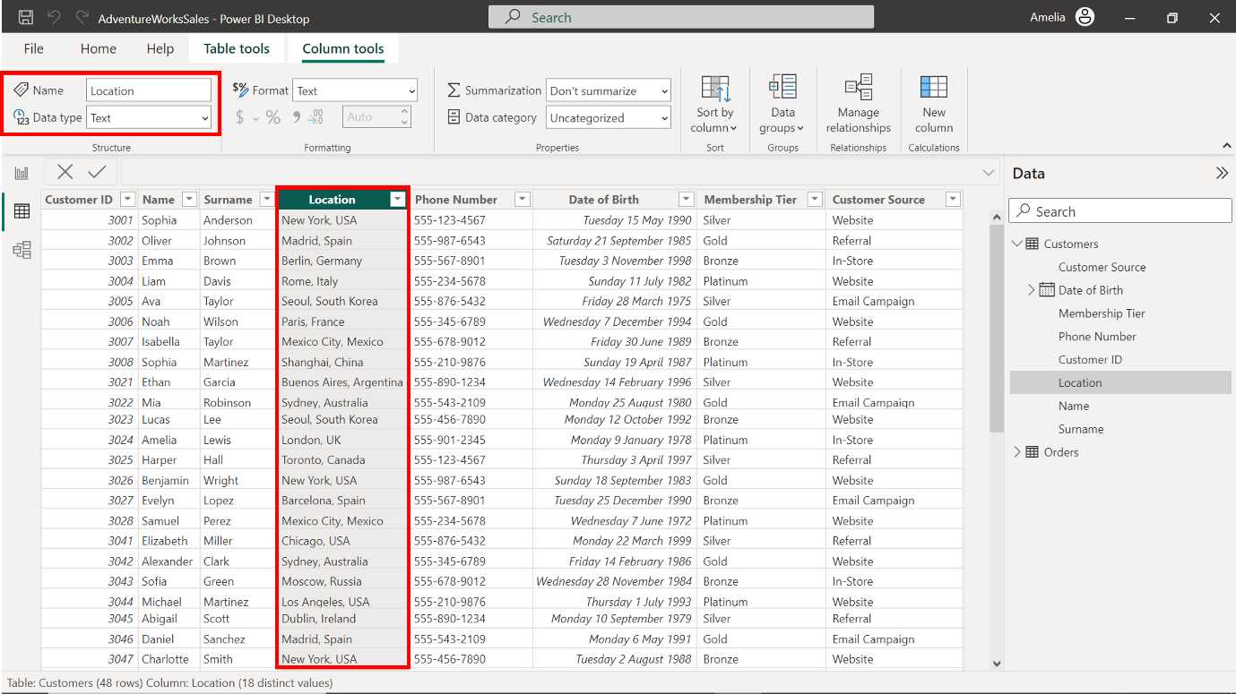
- Change the data type of the Phone number column to Text.
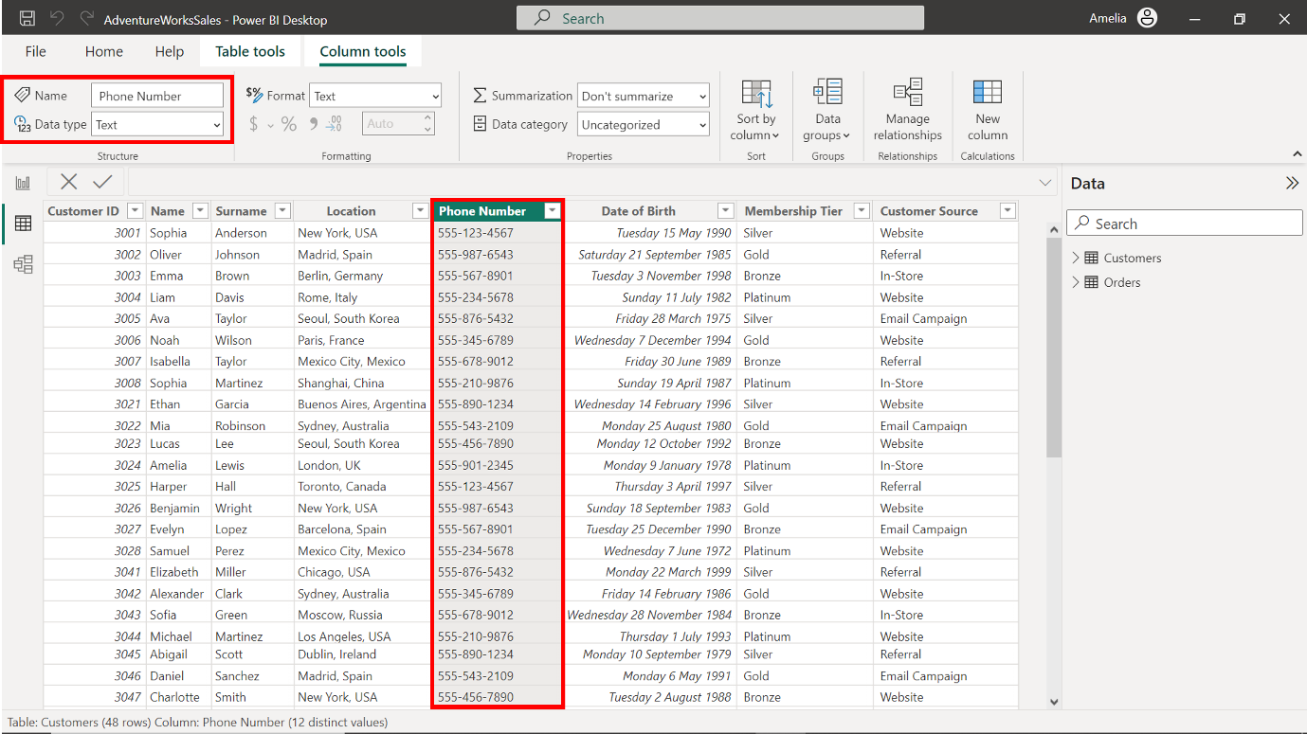
- Change the data type of the Date of Birth column to Date.
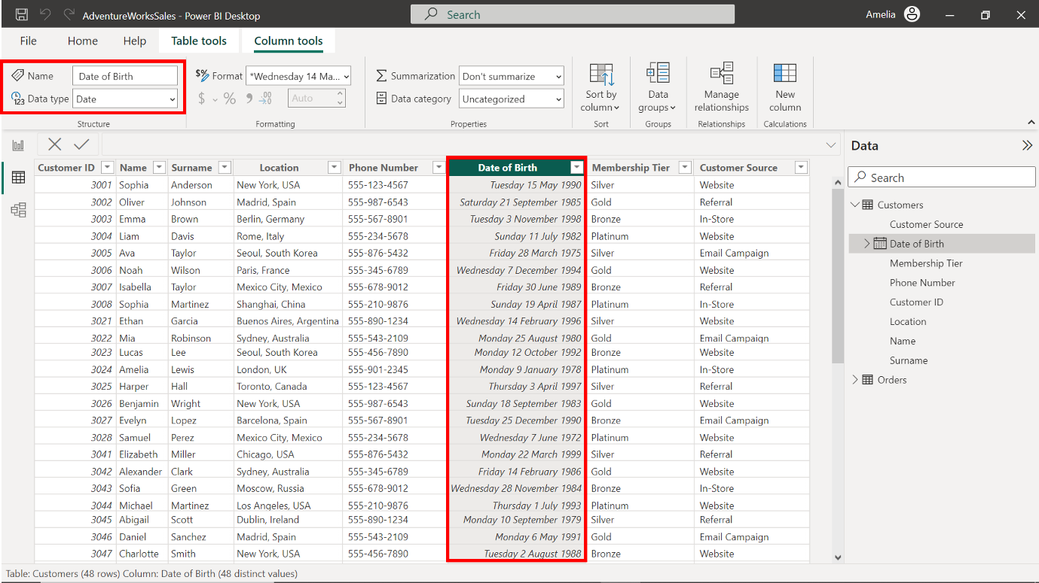
- Change the data type of the Membership Tier column to Text.
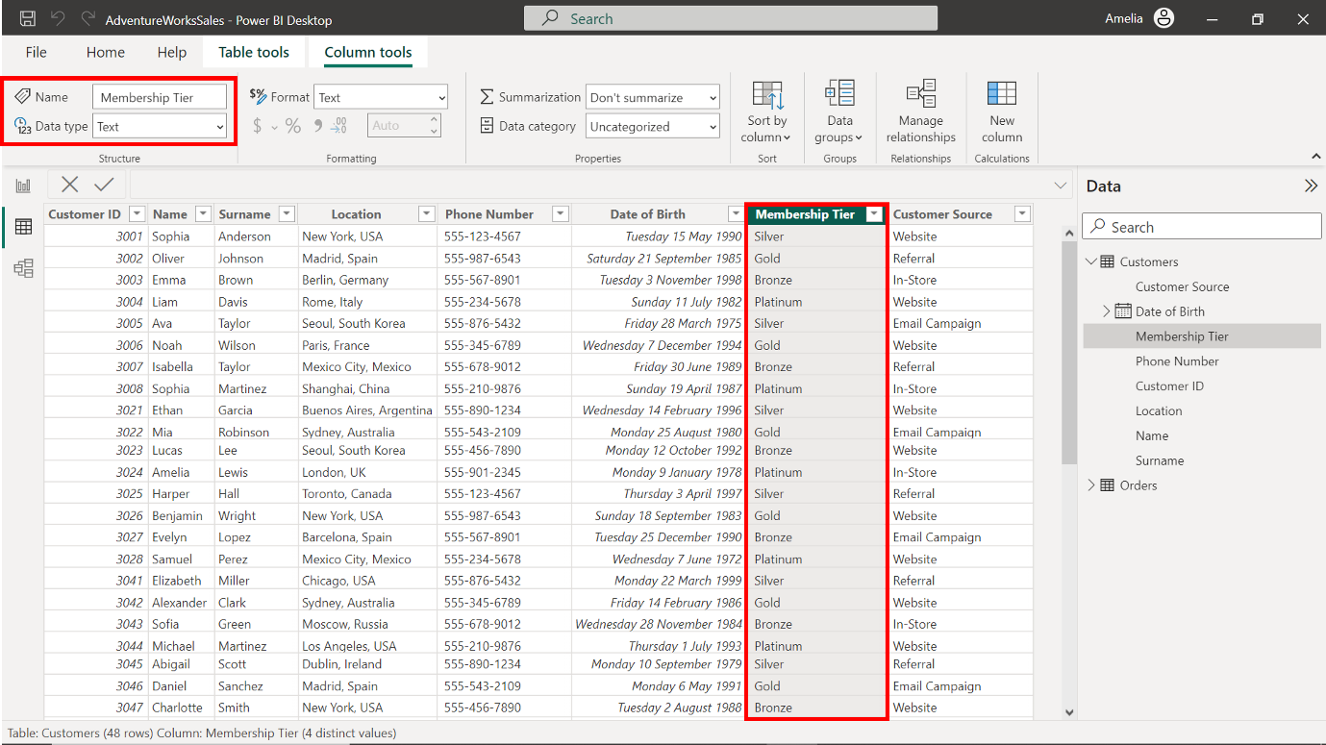
- Change the data type of the Customer Source column to Text.
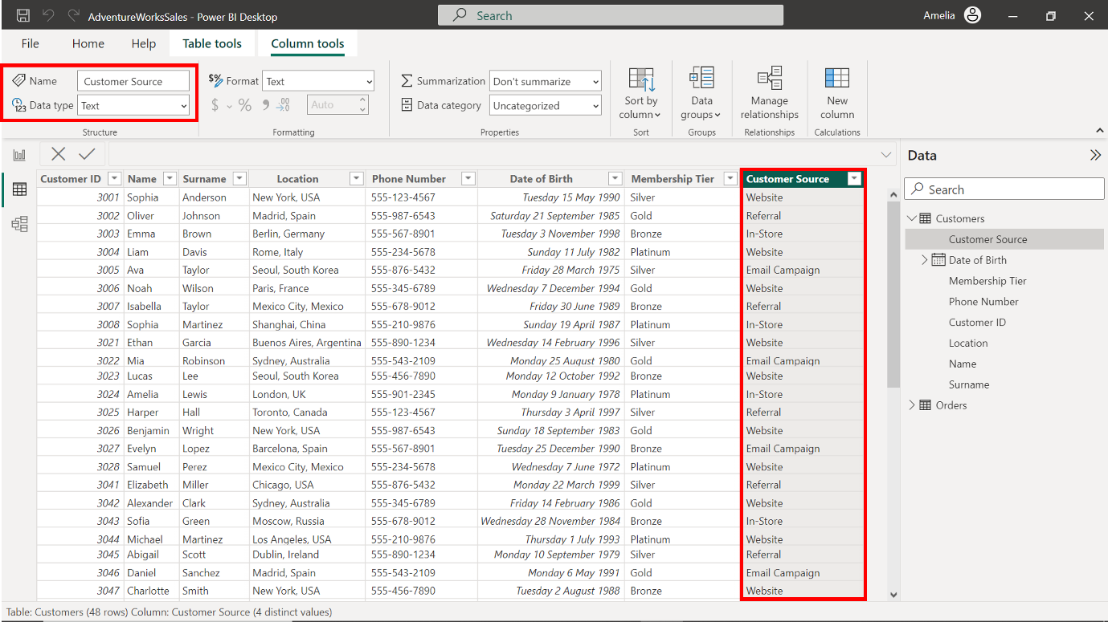

Optimizing Data Types for the Orders table
- Select the Orders table from the Fields pane to bring its columns into focus.
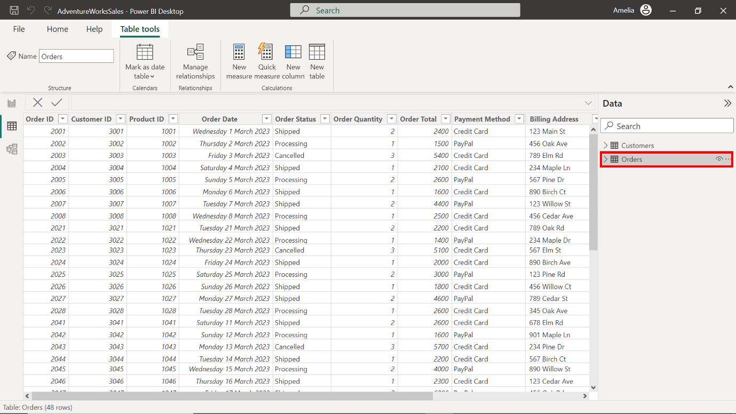
- Observe the first ten records. The Credit Card payment method was selected six times, notably more frequently than other payment methods. Product ID 1003 was ordered three times. Its repeated appearance suggests a high demand for this product.
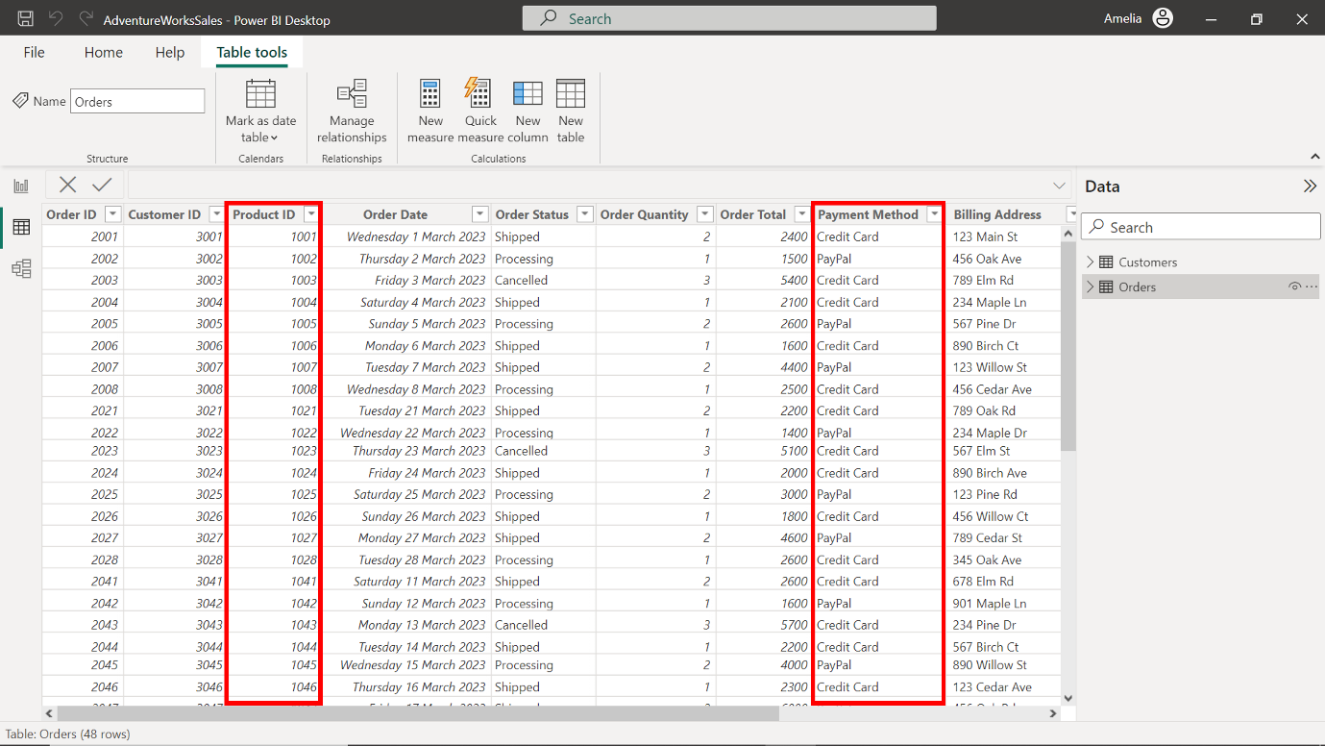
- Access the Column tools tab on the top toolbar. Select the option labeled Data type.
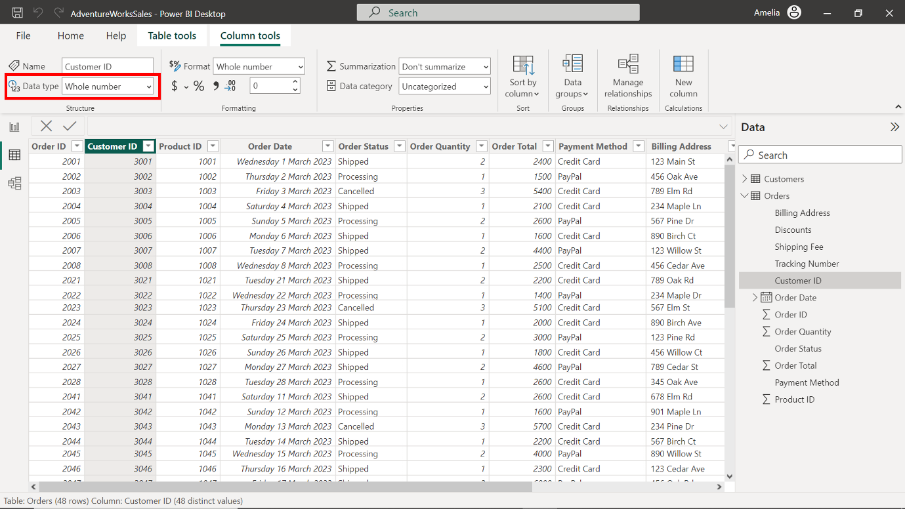
- Each column in Adventure Works' Orders table holds significant business value. To complete the optimization of the table, assign the following data types to the columns:
- Change the data type of the Order Total column to Decimal number.
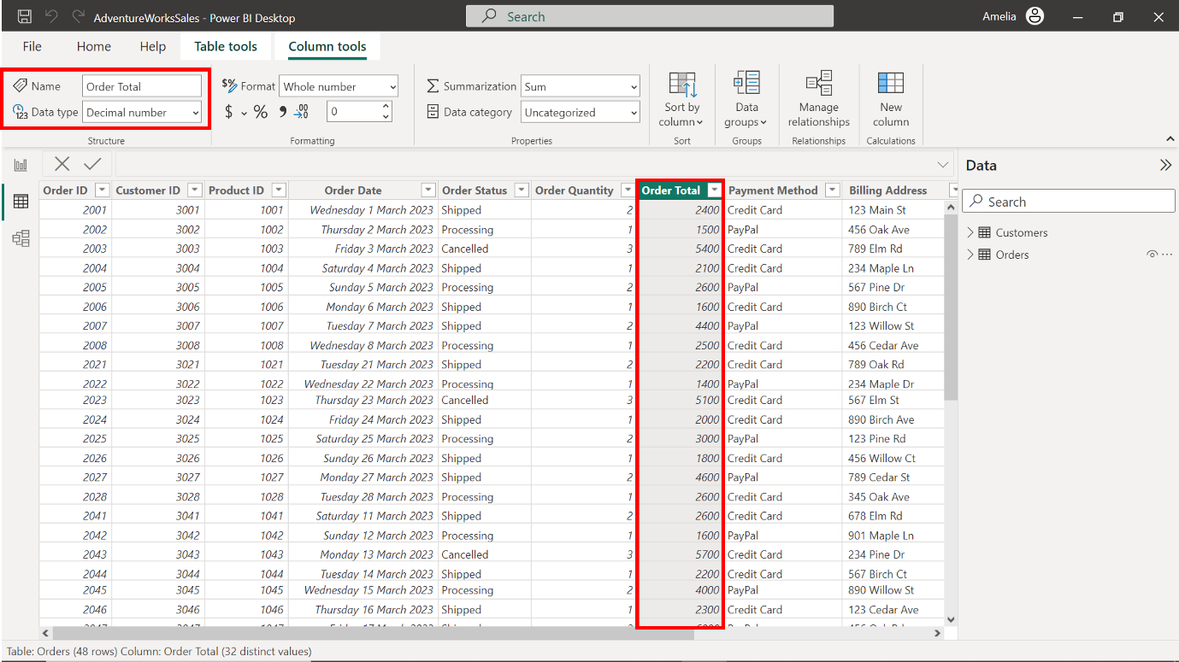
- Change the data type of the Order ID column to Whole number.
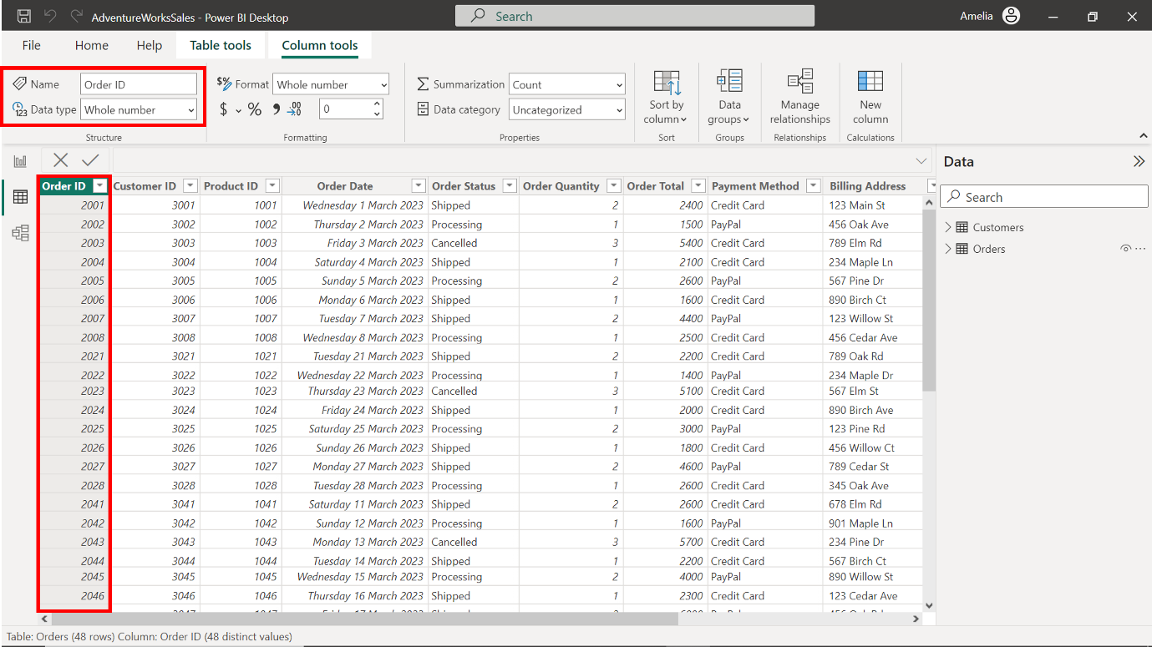
- Change the data type of the Customer ID column to Whole number.
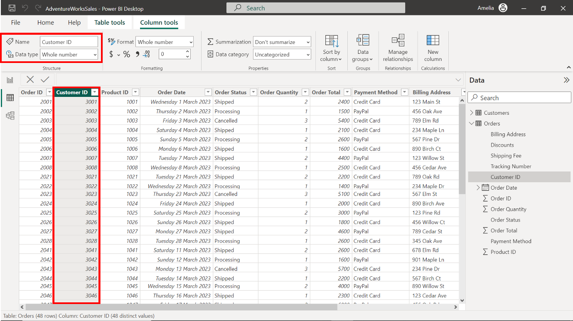
- Change the data type of the Product ID column to Whole Number.
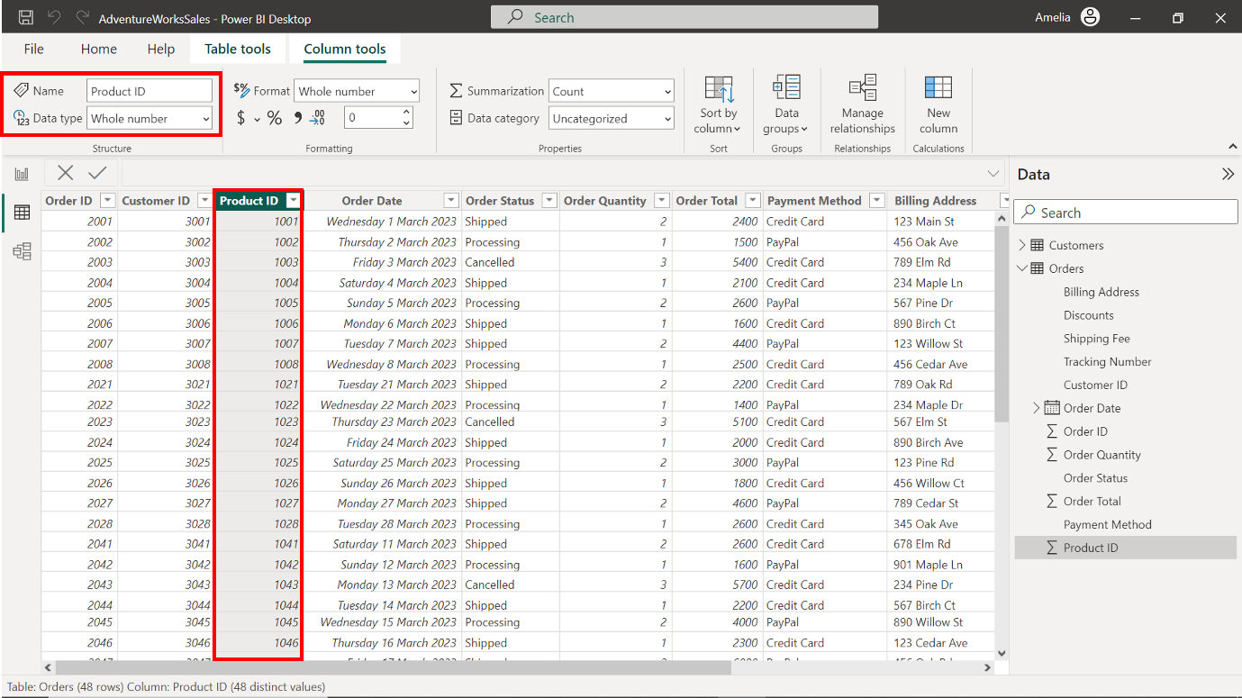
- Change the data type of the Order Date column to Date.
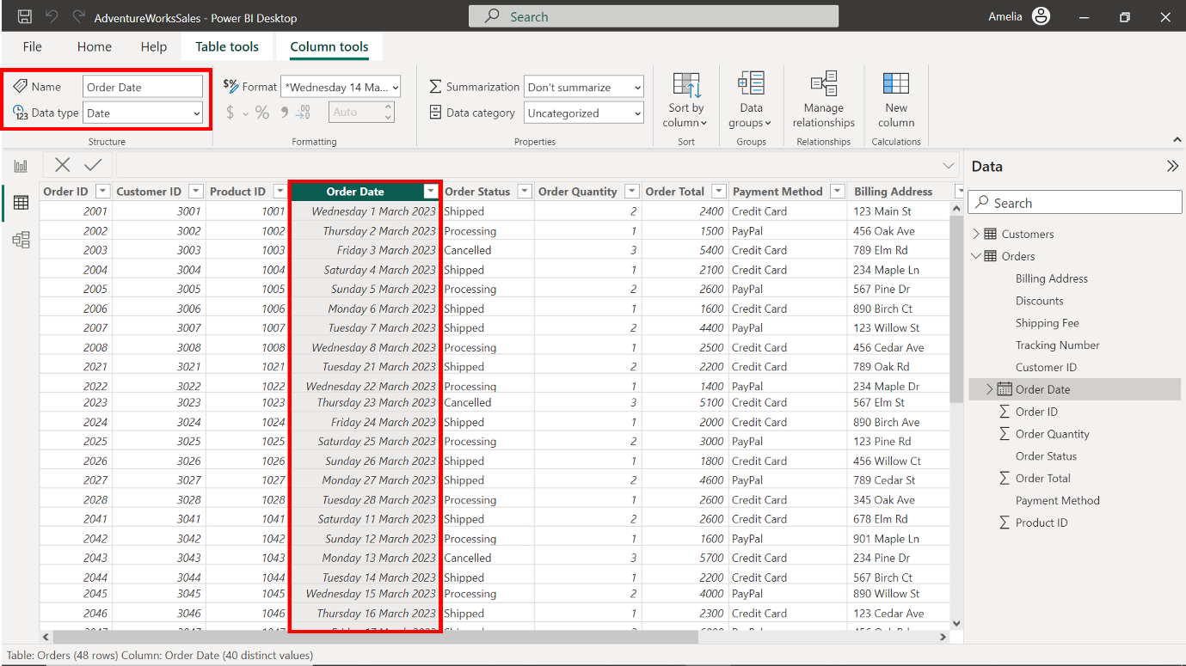
- Change the data type of the Order Status column to Text.
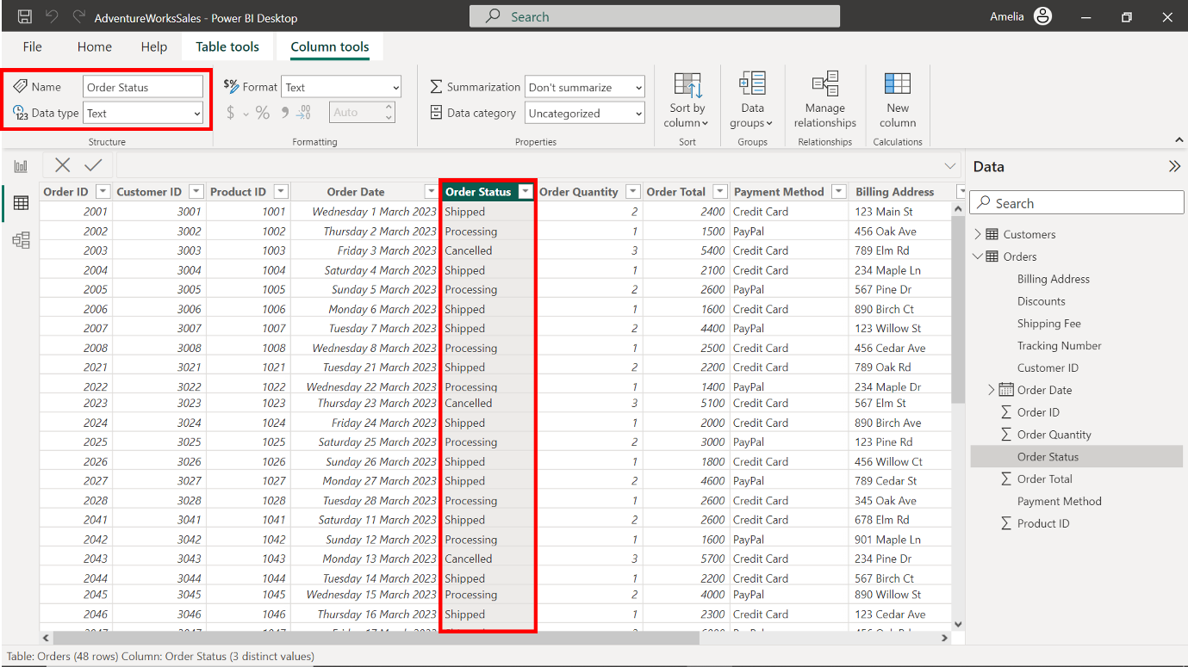
- Change the data type of the Order Quantity column to Whole Number.
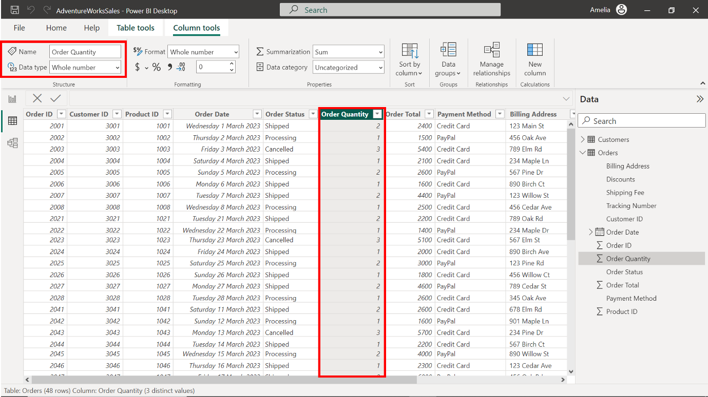
- Change the data type of the Payment Method column to Text.
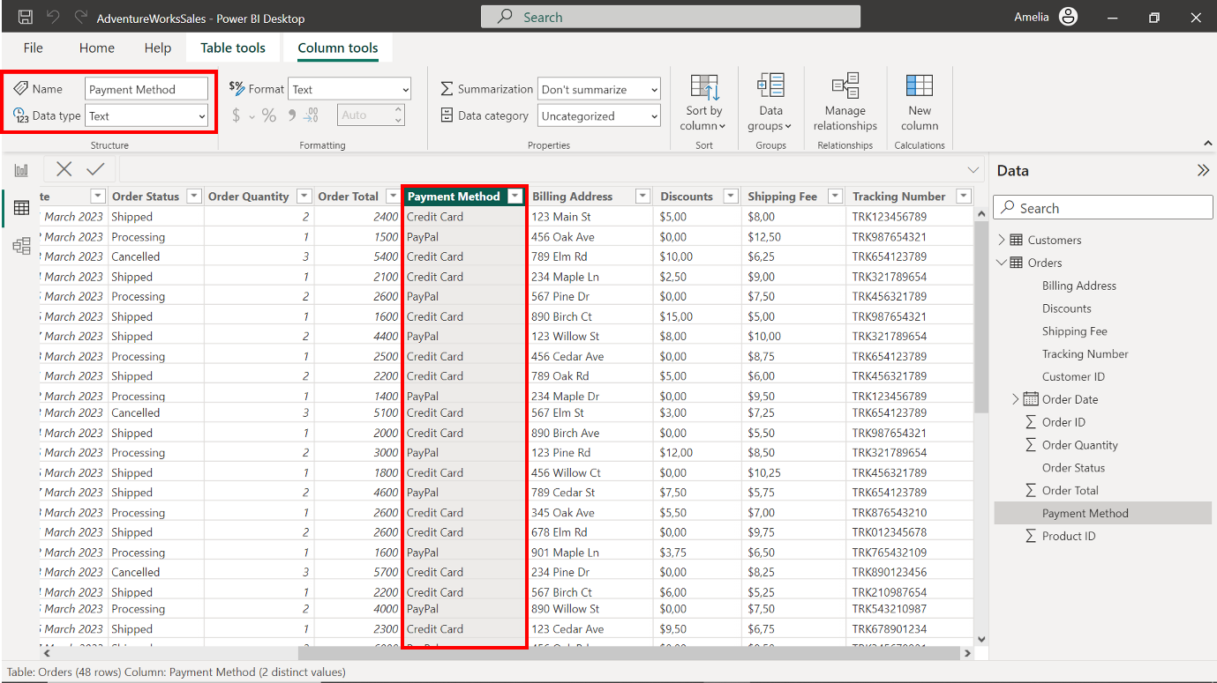
- Change the data type of the Billing Address column to Text.
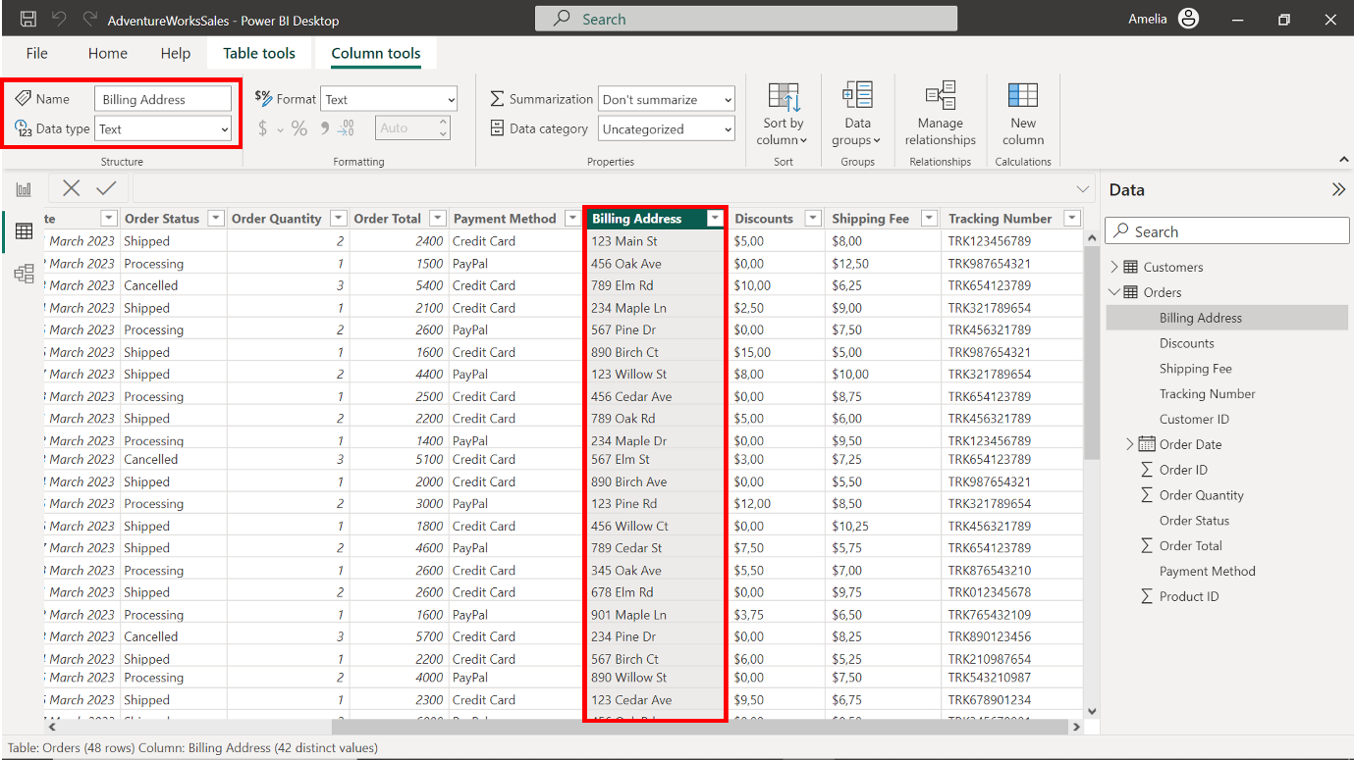
Change the data type of the Discounts column to Decimal Number.
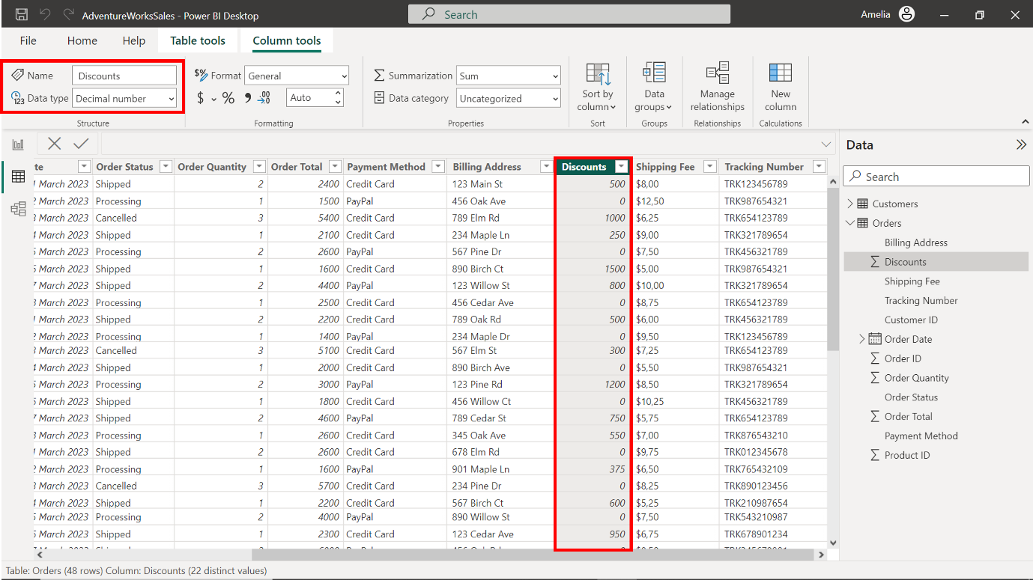
Change the data type of the Shipping Fee column to Decimal Number.
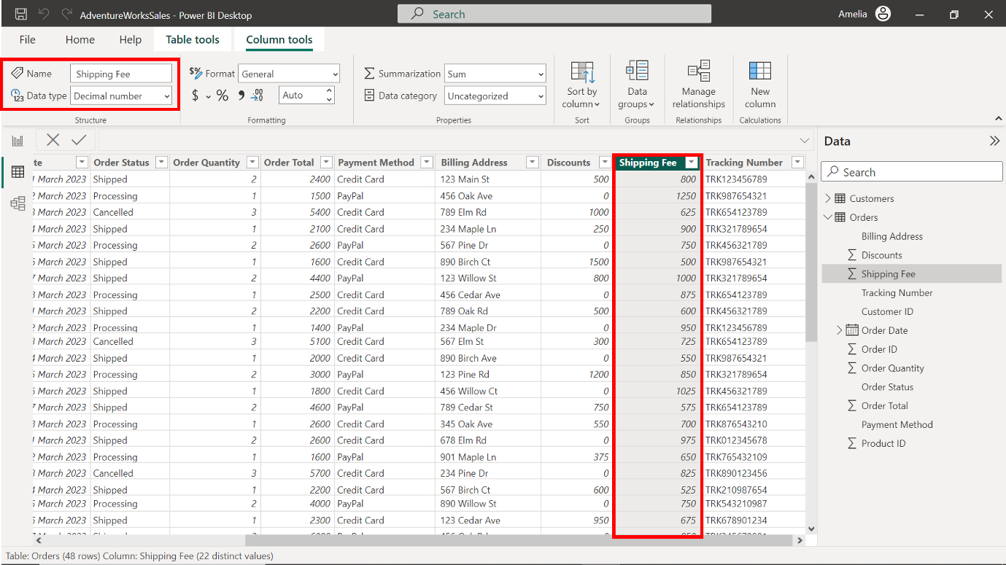
- Change the data type of the Tracking Number column to Text.
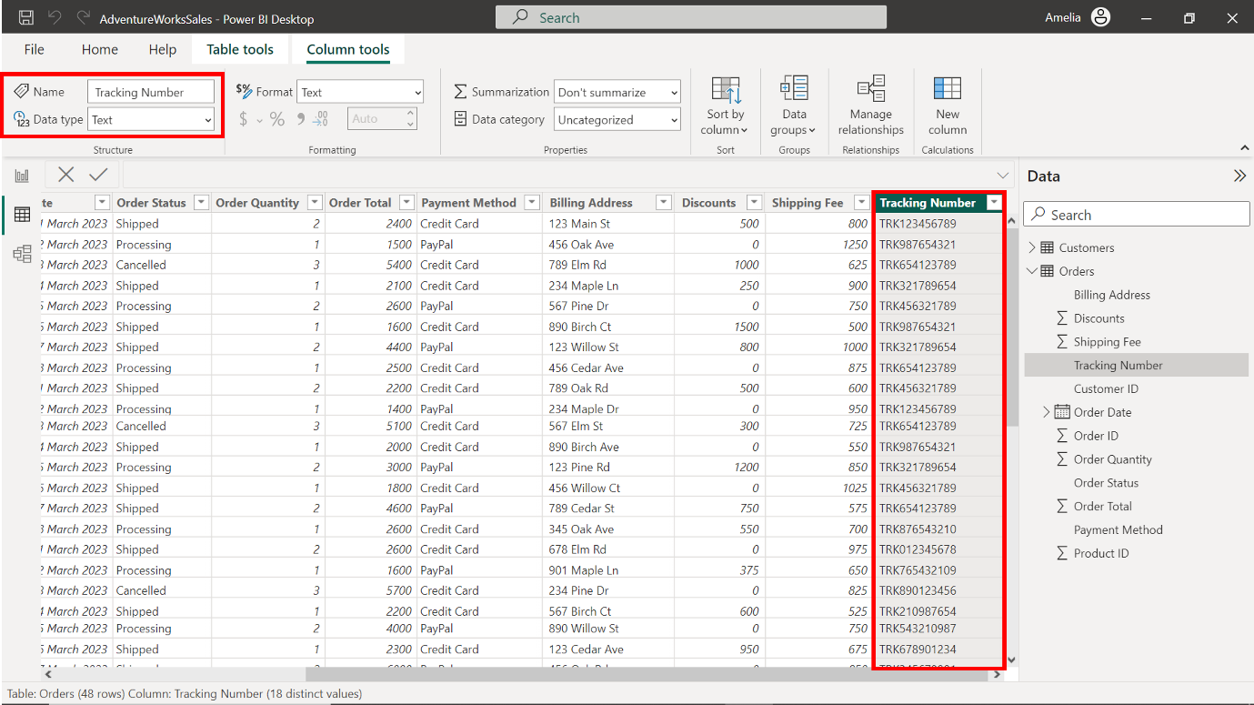

Step 4: Build and configure the model relationships.
- Locate and select the Model icon on the left toolbar. This transitions your workspace into the Model View, which vividly represents tables and their inter-relationships.
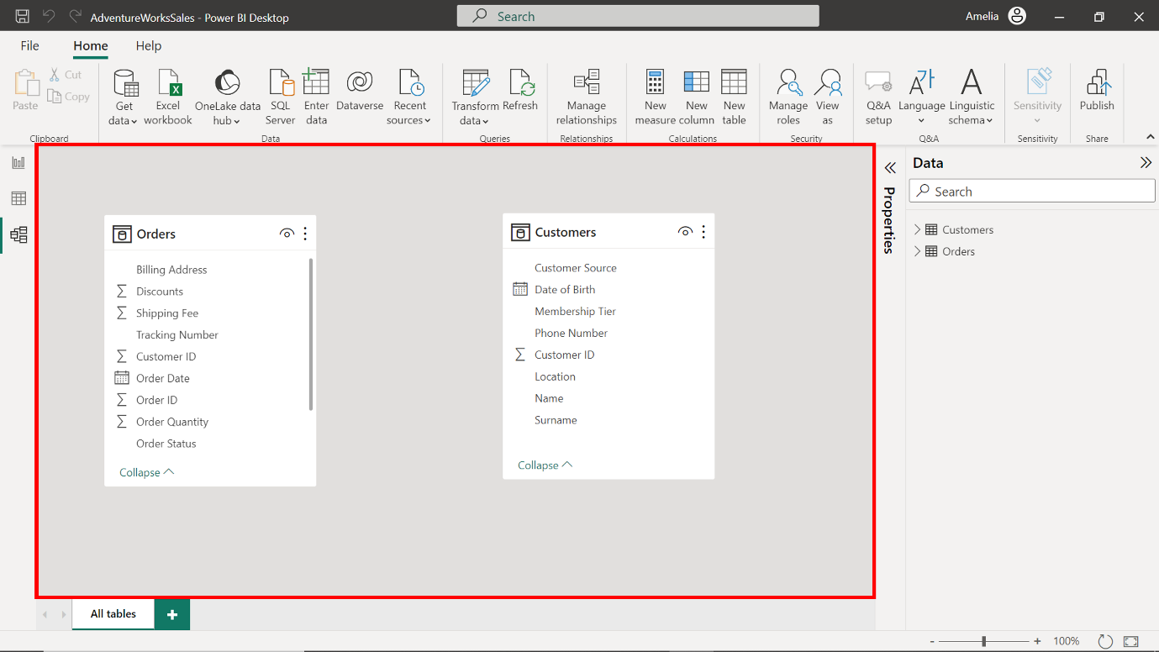
- In the Customers table, the Customer ID is a unique identifier for every customer. The Customer ID column also exists on the Orders table. This indicates which customer placed each order. This commonality between the tables can be used to establish a relationship. Select the Customer ID field in the Customers table. Hold down the selection and drag a connecting line to the Customer ID field in the Orders table.
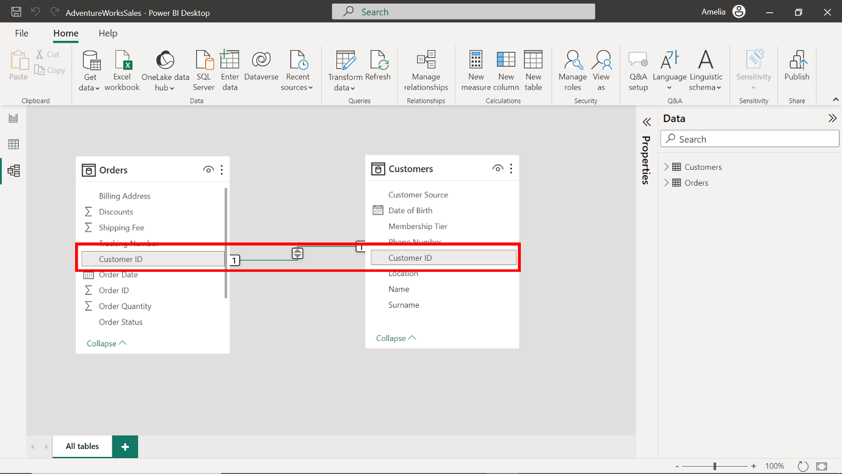
- Next, let’s define the type of relationship. Double-click on the connecting line you've drawn between the tables to open the Properties pane. In the context of Adventure Works, one customer (from the Customers table) can have multiple orders (in the Orders table). Hence, this is a One-to-many relationship.
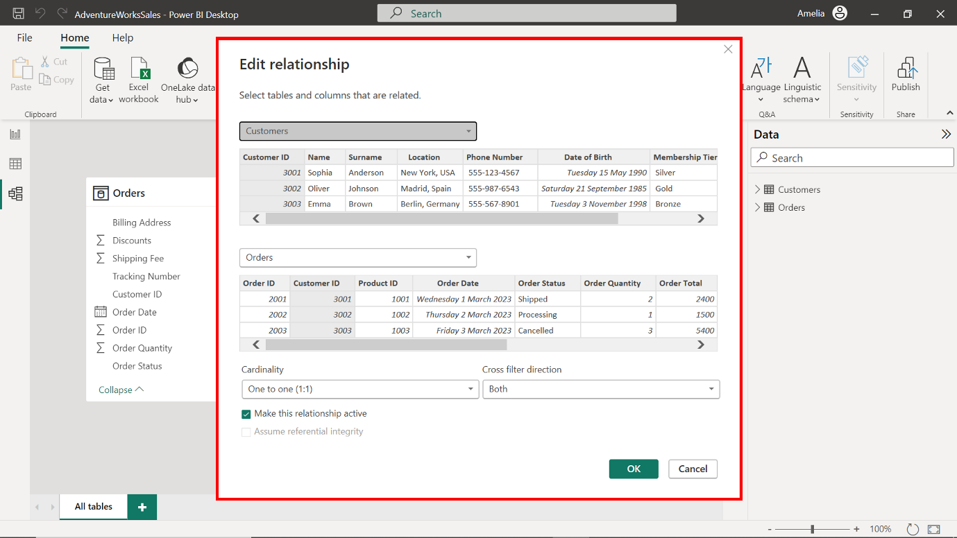
- For Cardinality, change the selection from its current state to One-to-many to improve performance (One-to-many relationships are often simpler and faster for Power BI to navigate when loading data and calculating results.)
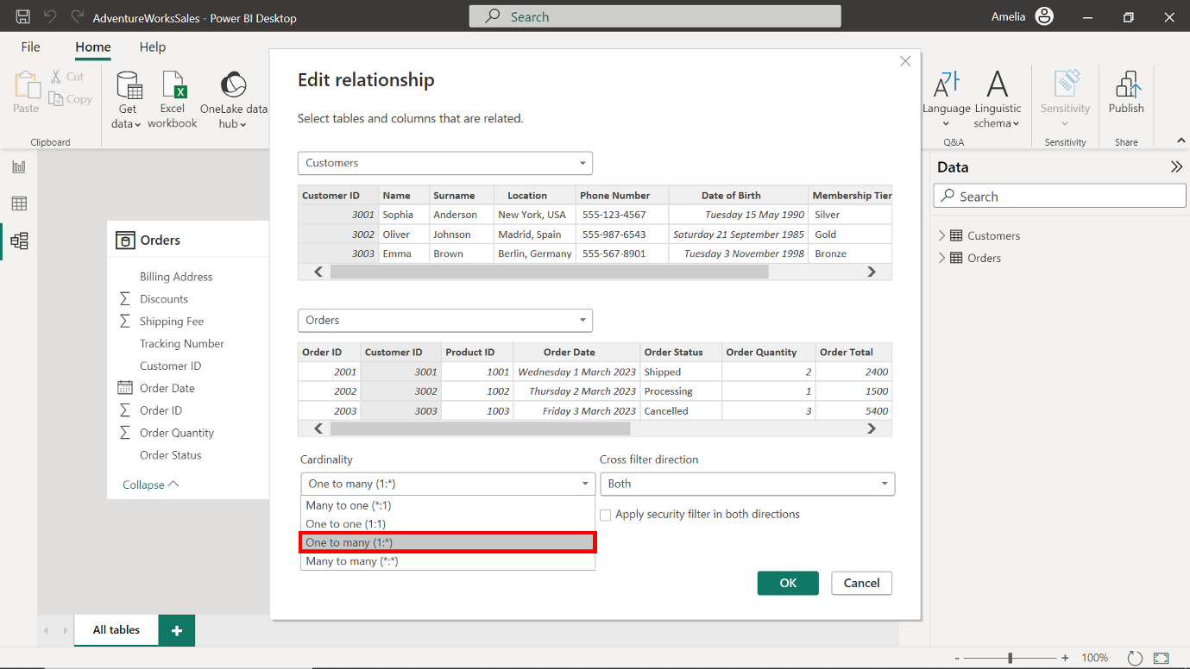
- To establish a cross-filter direction, choose the Single option. By keeping the filter direction singular, you can maintain a simplified data model, ensuring quick and efficient data retrievals.
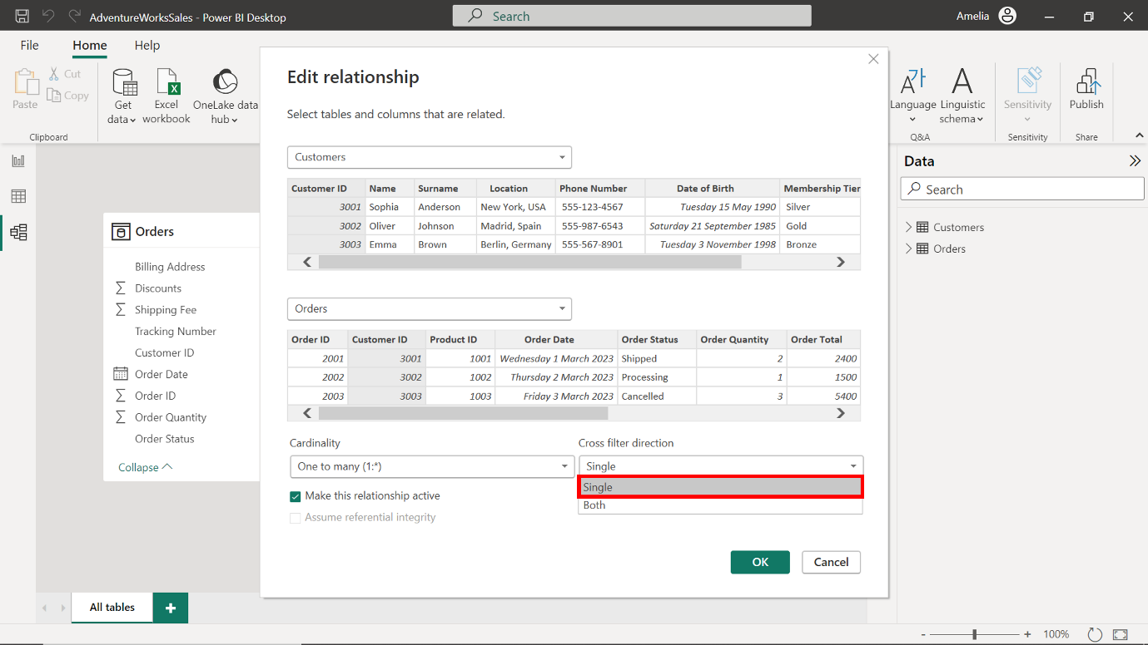
- To save the changes made to the data model, select the OK button at the bottom right corner of the dialog box.
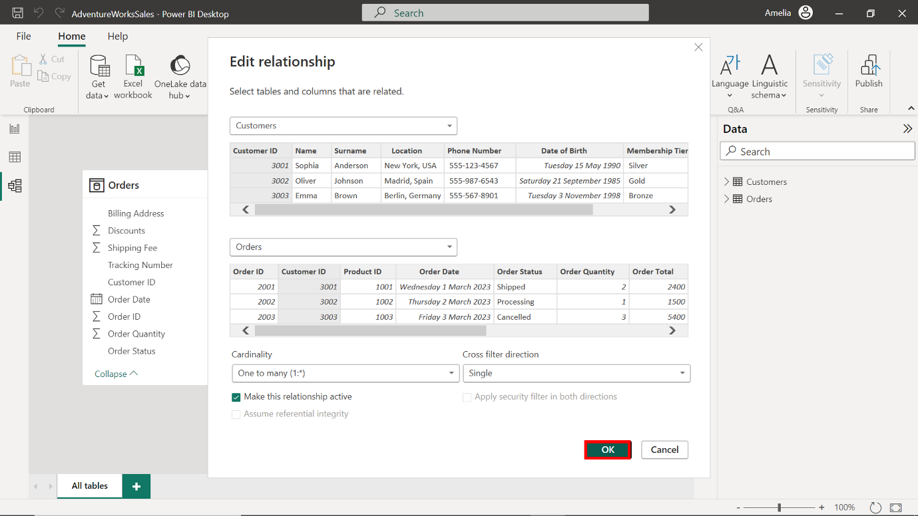

Step 5: Disable Auto/Date Time
- Select the File tab in the toolbar. From the dropdown menu, select Options and settings, then select Options. This option contains several sub-options that allow you to customize and control various aspects of Power BI.
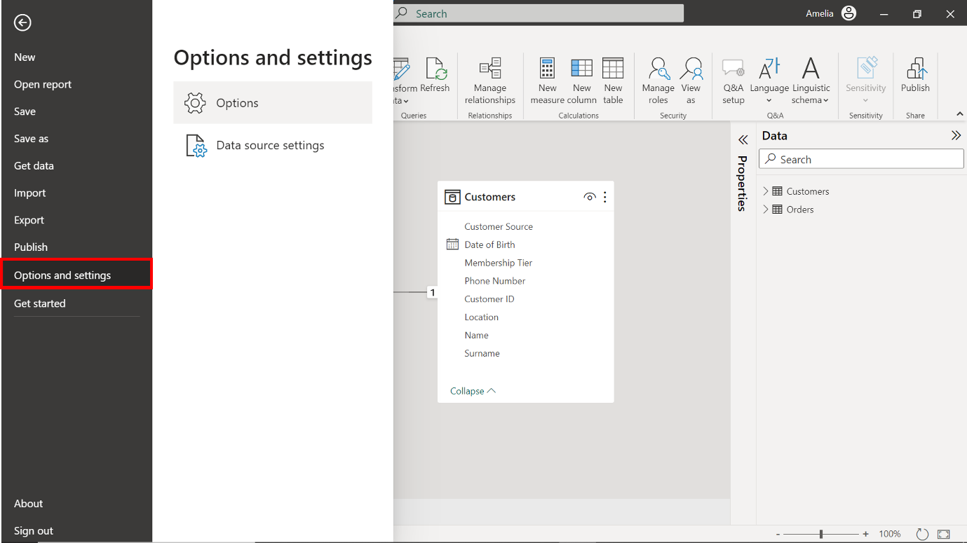
- An Options window appears onscreen. Select Data Load under the Current file section from the Options on the left-hand side of the window.
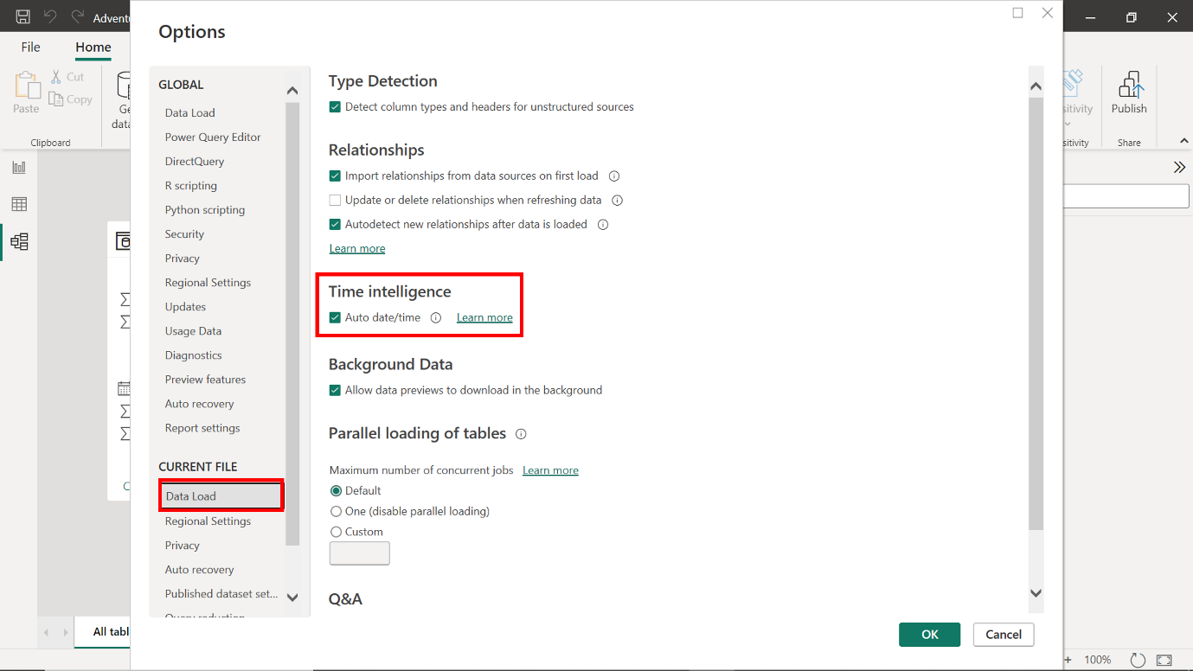
- In the Data Load options is a checkbox labeled Auto date/time. This box is checked by default, which means the feature is enabled. Uncheck this box to turn off the current file's Auto Date/Time feature.
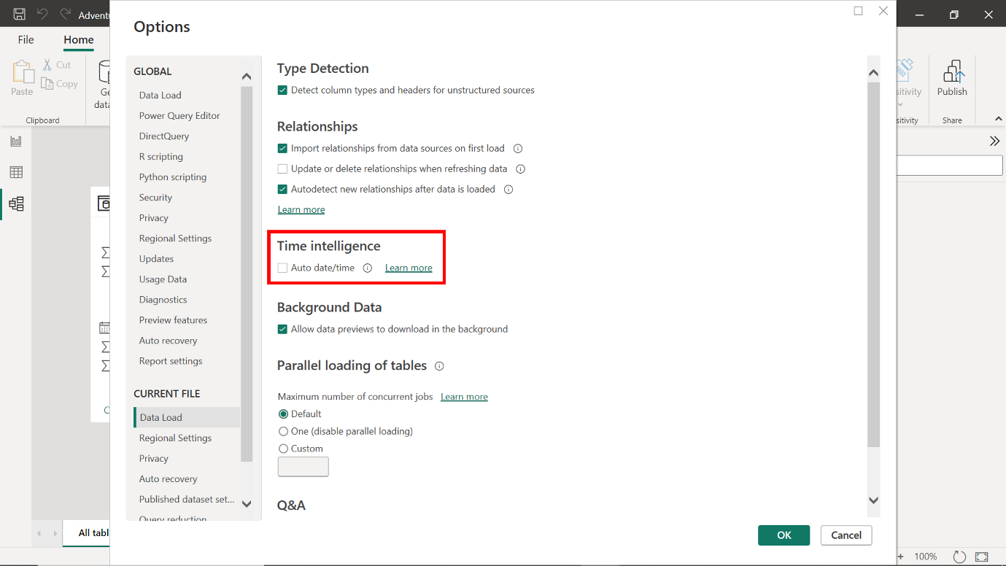
- Select OK to apply the changes. This enables Adventure Works teams to retain greater control over how date information is displayed in their reports.
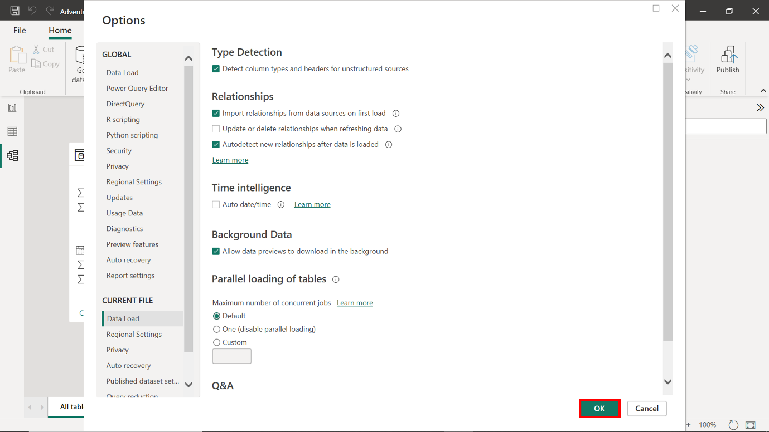

Conclusion
By completing these steps, you have successfully built, configured, and optimized a data model for Adventure Works.

